TEEA County Association List of Presidents and EINs - County Form
- County Association Chair, print or type information of all clubs and county association, one list per county.
- List all Employee Identification Numbers (EIN) of clubs, county association, club and county name, Association Chair, Club Presidents and their addresses.
- If a club is no longer active, list the EIN and the last valid address provided to the IRS; then write “ INACTIVE” beneath the address.
- Send four (4) copies to the District Director by August 1. The District Director will keep 1 copy and forward 1 copy to the TEEA President, 1 copy to the TEEA Treasurer, and 1 copy to the 990 Consultant by August 15.

District County Date
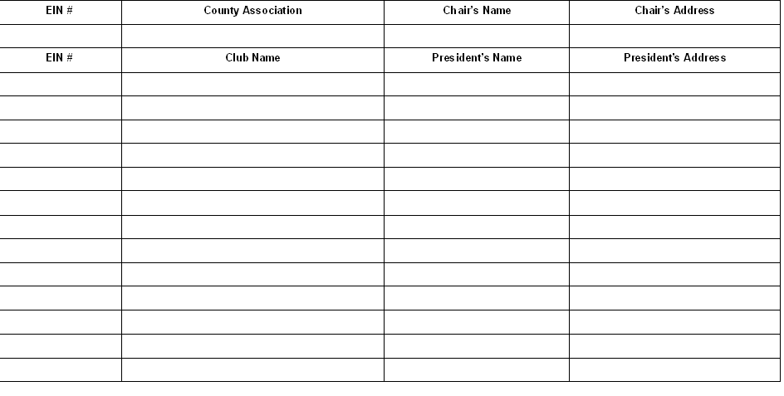
9/21

